**LAB 23 My SQL Murder Mystery**

SELECT description FROM crime_scene_report

WHERE date = '20180115'AND city = 'SQL City'AND type = 'murder';

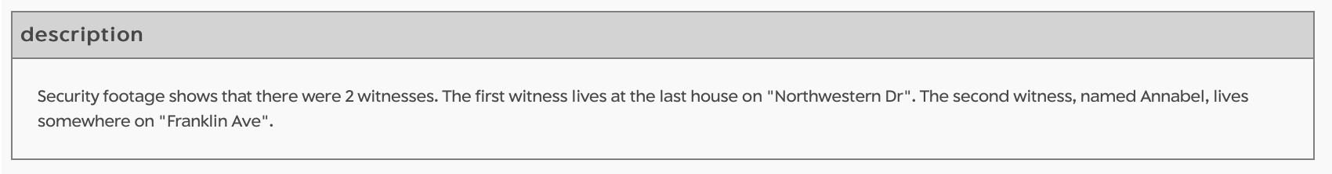

SELECT * FROM person

WHERE name Like 'Annabel%' AND address_street_name = 'Franklin Ave'; 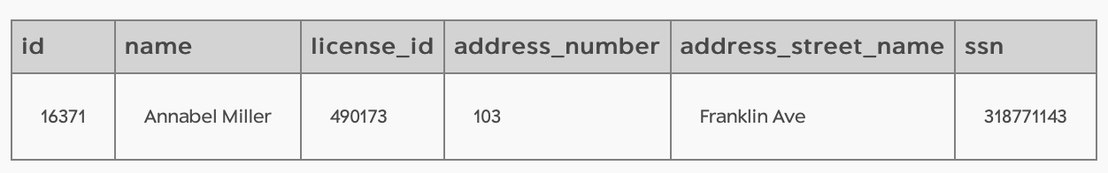

SELECT transcript FROM interview

WHERE person_id = '16371';

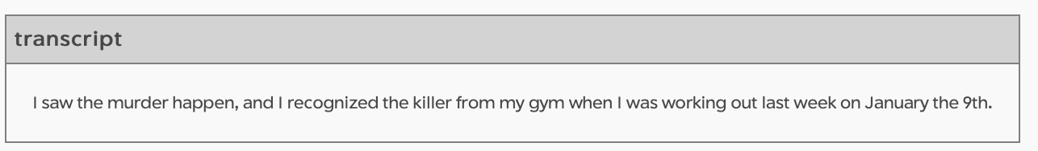

SELECT * FROM person

WHERE address_street_name = 'Northwestern Dr'

ORDER BY address_number DESC

LIMIT 1;

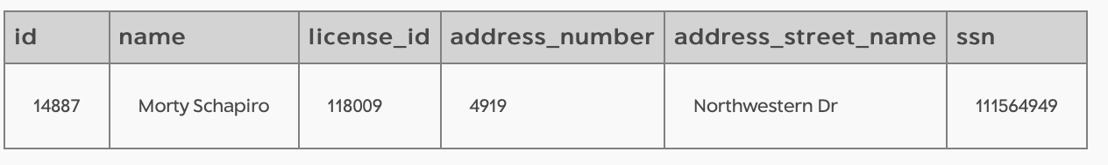

SELECT transcript FROM interview

WHERE person_id = '148871';

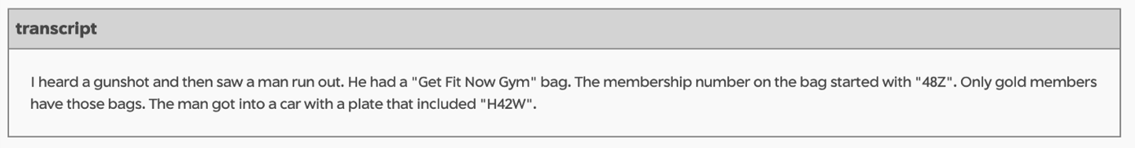

SELECT membership_id

FROM get_fit_now_check_in

WHERE membership_id LIKE ‘48Z%’ AND check_in_date = ‘20180109’;

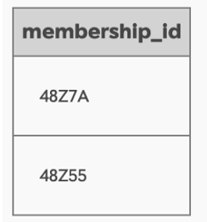

SELECT * FROM get_fit_now_member

WHERE id = ‘48Z7A’ OR ‘48Z55’ membership_status = ‘gold’

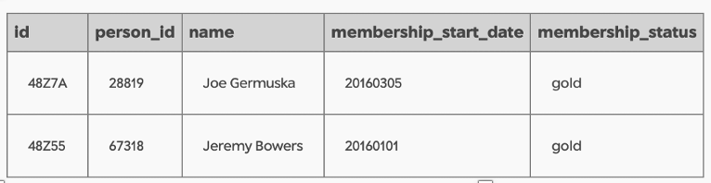

SELECT p.name, d.plate_number

FROM person AS p

JOIN drivers_license AS d

ON p.license_id = d.id

WHERE p.name = ‘Joe Germuska’ OR p.name = ‘Jeremy Bowers’;

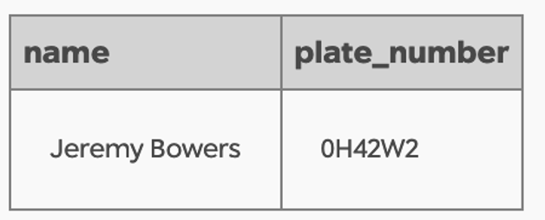

SELECT transcript

FROM interview

WHERE person_id = ‘67318’;

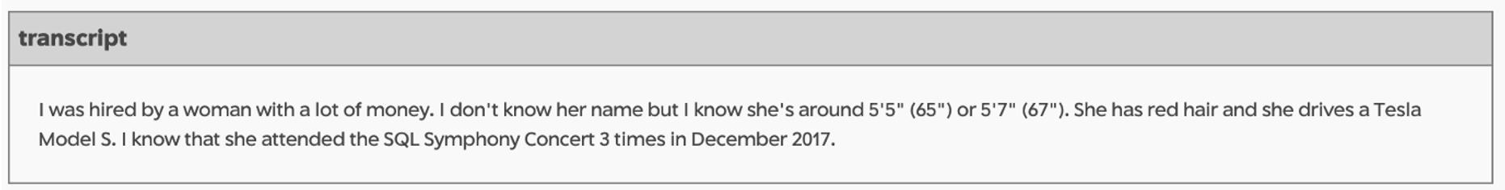

SELECT p.name, d.height, d.hair_color, d.car_make, d.car_model, d.gender

FROM drivers_license AS d

JOIN person as p

On d.id = p.license_id

WHERE d.height BETWEEN 65 AND 67 d.hair_color = ‘red’ AND gender = ‘female’

AND car_make = “Tesla’ AND car_model = ‘Model S’

AND p.id IN (SELECT f.person_id

FROM facebook_event_checkin as f

WHERE f.event_name = ‘SQL Symphony Concert’

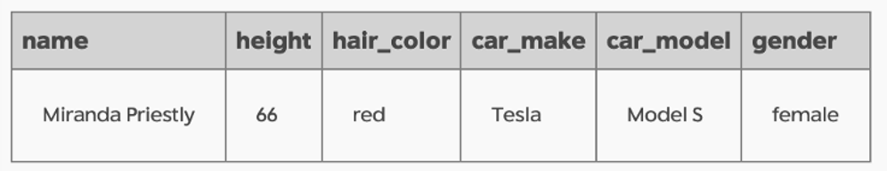

INSERT INTO solution VALUES (1, 'Miranda Priestly');

SELECT value FROM solution;

